A] HISTOGRAM
Q1 Class: 0-25 25-50 50-75 75-100 100-125
f 5,8,13,11,3
CODE:
lb=seq(0,100,25)
ub=seq(25,125,25)
f=c(5,8,13,11,3)
x=(lb+ub)/2
y=rep(x,f)
cls=seq(0,125,25)
hist(y,breaks=cls)
OUTPUT:
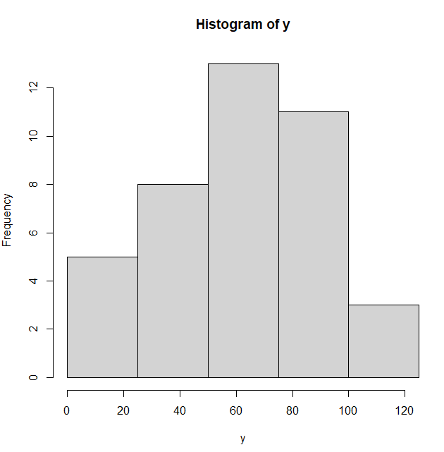
Q2. Class: 10-20 20-30 30-40 40-50 50-60 60-70
Fre: 5 12 22 10 8 3
CODE:
lb=seq(10,60,10)
ub=seq(20,70,10)
f=c(5,12,22,10,8,3)
x=(lb+ub)/2
y=rep(x,f)
cls=seq(0,125,25)
hist(y,breaks=cls)
OUTPUT:
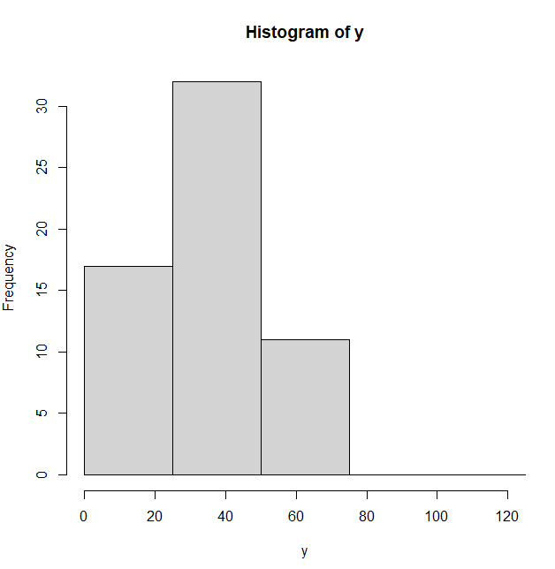
B] EIGEN VALUES AND EIGEN VECTOR
Q1. a=c(4,1,3,2)
CODE:
a=c(4,1,3,2)
A=matrix(a,nrow=2,,ncol=2)
A
eigen(A)
OUTPUT:
> a=c(4,1,3,2)
> A=matrix(a,nrow=2,,ncol=2)
> A
[,1] [,2]
[1,] 4 3
[2,] 1 2
> eigen(A)
eigen() decomposition
$values
[1] 5 1

$vectors
[,1] [,2]
[1,] 0.9486833 -0.7071068
[2,] 0.3162278 0.7071068

Q2. b=c(5,7,2,1)
CODE:
b=c(5,7,2,1)
A=matrix(b,nrow=2,,ncol=2)
A
eigen(A)
OUPUT:
> b=c(5,7,2,1)
> A=matrix(b,nrow=2,,ncol=2)
> A
[,1] [,2]
[1,] 5 2
[2,] 7 1
> eigen(A)
eigen() decomposition
$values
[1] 7.242641 -1.242641

$vectors
[,1] [,2]
[1,] 0.6655791 -0.3051016
[2,] 0.7463273 0.9523198

